Summary of Trailer Data Collection v1.0

Mike Ma
Table of Contents
1. Data Introduction 1
1.1 Data Source 1
1.2 Data Introduction 3
1.3 Personal Opinion About Data 10
2. Tools and Methods 12
3. Operate Steps(Run yourself or get more data) 12
4. Extended Program 18
5. Summary 18
Four parts of my task: 18
6. Problems and Improvements 19

Data Introduction

1.1 Data Source
- YouTube- Movieclips Trailers ( 8K+ official trailers & 14M+ subscribers )
https://www.youtube.com/user/movieclipsTRAILERS
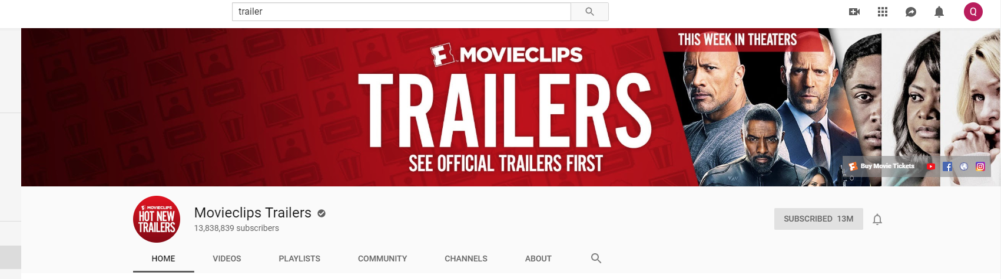
- Twitter
https://twitter.com/BestTraiIers(480 Tweets, 144K Follower)

The problem is—trailers from twitter is not directly shared from YouTube, twitter has a special channel for trailers, so although the film name is the same, if one film has multi trailers, the data from Twitter and YouTube is difficult to match.

Ex. The King’s Man trailer:
Youtube:
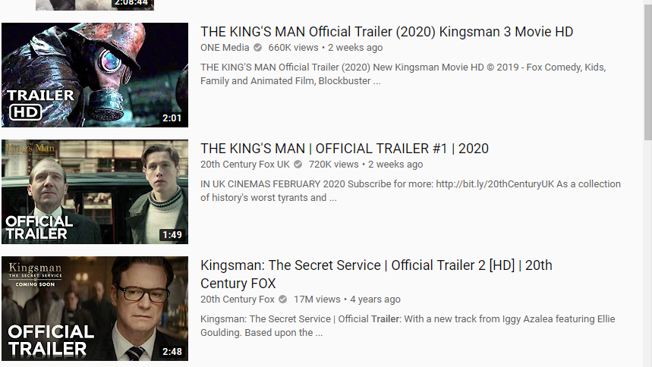
However in Twitter:

No #1 or #2 to match
Personally I don’t think Twitter sharing analysis is necessary.(The multi types of data from Youtube are enough to judge viewer’s preference and the popularity of a trailer)

But if necessary, I could get the number of comments, sharing, like. (I have already got them)

1.2 Data Introduction
- Data-table: youtube_info_all
(All trailers published from 2018.1.1-2019.8.1, 700+trailers)
- Published time
- Title
- Full description
- Duration
- ViewCount
- LikeCount
- DislikeCount
- FavoriteCount(add this trailer as favorite video, hidden data)
- commentCount(How many comments)

Mysql database ex:
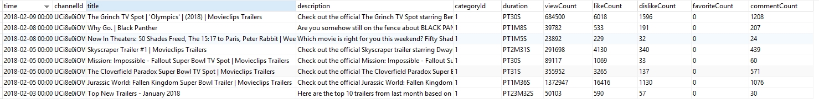
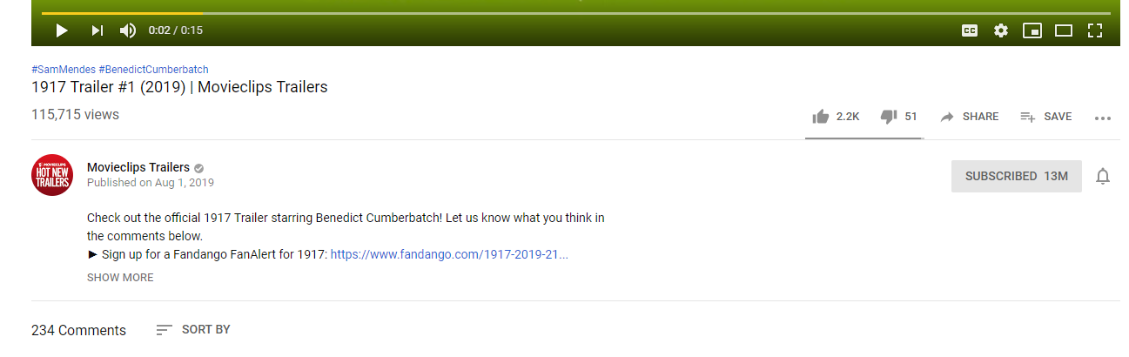
- Data-table: youtube_trailer_comments_thisweektrailer
(All comments from trailers at This Week Trailer, 8400+comments from about 10 trailers in this channel, some trailers have more than 10K comments, so it need to be selected, this data table is whole comments from 10 trailers)


- Title of Trailer
- Video Link()
- Comments
- CommentsLike(how many likes this comment get)
- Comments Time
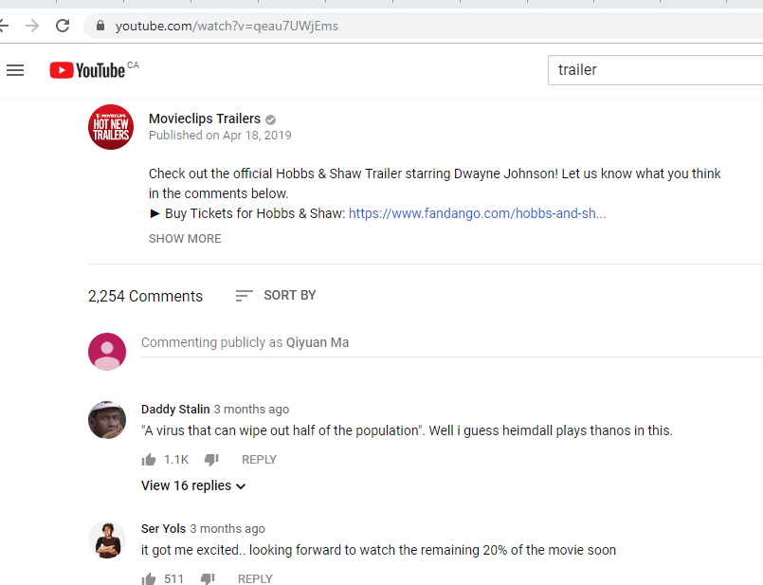
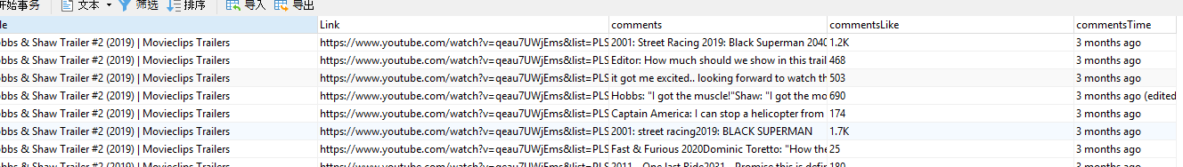
- Data-table: youtube_trailer_comments_selected_thisweektrailer
(Selected comments from trailers at This Week Trailer, 800+comments from about 10 trailers in this channel, I only collect the comments which Commentslike>5, reduce more than 9/10 valueless comments)
- Title of Trailer
- Video Link()
- Comments
- CommentsLike(how many likes this comment get)
- Comments Time
- Data-table: youtube_trailer_comments_selected_Action (Still Running the program)
(Selected Comment from trailors at Action Category, ,55,000+Comments from 500+trailers,collect the comments which Commentslike>5)
(If necessary, I could get all comments from trailers at all different categories, but it need too much time to run, personally I think use a typical category like Action Trailers is enough, because to run NLP to analysis comments attitude also need much more time than scrapping data).
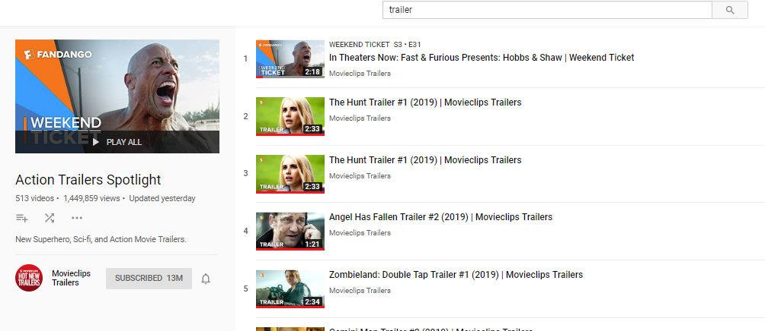
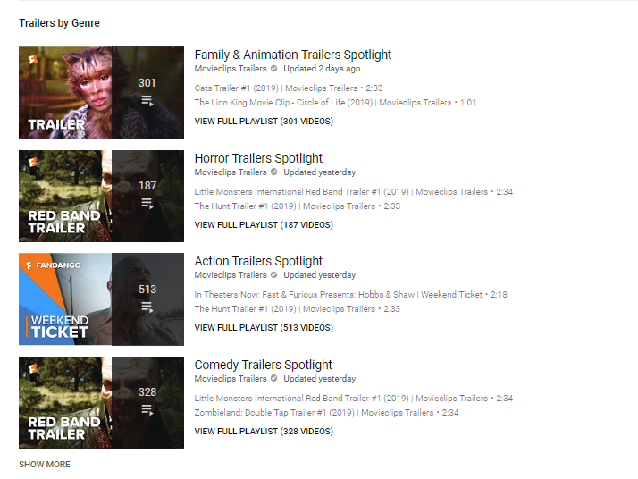
https://www.youtube.com/playlist?list=PLScC8g4bqD45-Bue4BX7U2h4IkzEV3hcL

- Downloaded File: All trailers videos at all different categories.
(All trailers downloaded and sorted as categories, 40GB, 720P, MP4, name is same as “Title” at database, about 3000 trailers)
Categories:
- 720P Biographical Trailer Spotlight
- 720P Comedy Trailers Spotlight
- 720P Drama Trailer Spotlight
- 720P Family & Animation Trailers Spotlight
- 720P Horror Trailers Spotlight
- 720P Hot Docs - New Documentary Trailers
- 720P NEW INDIE TRAILERS
- 720P Thriller Trailers Spotlight
- 720P Action Trailers Spotlight
Supported format:
1080P FullHD
720P HD
480P VGA
360P SD
240P HQVGA
144P Low
128P Kb/s
I don’t know the video analysis need how clear the video should be, so I choose the 720P, I don’t have experience of video analysis, but according to previous experience of image analysis(image classification prediction using Alexnet) , I’m sure to run the program need huge time. High quality could get higher accuracy, however, I strongly recommend 144P if the result could be accepted. I use a software to download the videos, so download 144P you just need to press a button.(in the following pages I would introduce)

Besides, save videos into database is bad idea. If we would use python to do video analysis, we just need to open the file in python(like my previous image analysis).

Personally I think video analysis is still a immature technique. I don’t know many algorithms about them.



- Data-table: Twitter_trailers_info_all
(All 480 tweets including Title, URL, Comments, Tweet Time, LikeCount, ShareCount, ReplyCount, From, @who)
Title
URL
Comments
Tweet Time
LikeCount
ShareCount
ReplyCount
From
@who
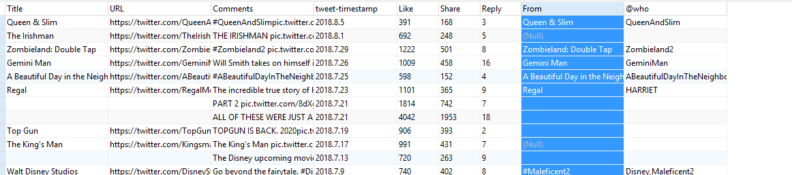


1.3 Personal Opinion About Data
- youtube_trailer_info_all
Title
Full description
Duration
ViewCount
LikeCount
DislikeCount
FavoriteCount
commentCount

- There are 5 Counts to decide the popularities of trailers and viewers’ preferences. These 5 Counts are not proportional, that means through analysing these number, we could know how controversial the trailer is. And Later through Comments Analysis using NLP, we could know the reason(or attitude, it’s easier) of controversy.

- Full description could use NLP algorithms to analysis the features of trailor and help decide what valuable description for a trailer should like.

3. Duration is also a feature of trailer.(Some people, like me, never see trailers shorter than 2min)

- youtube_trailer_comments_selected
Title of Trailer
Video Link()
Comments
CommentsLike(how many likes this comment get)
Comments Time
- Title of trailer in this table is same to the “Title” in table youtube_trailer_info_all, that means easy to inquire the video information at youtube_trailer_info_all after comments analyse .

- Personally I think one specific category trailer analysis(55,000+comments) is enough for writing lots of papers, but if in the future we want to get trailers at all different categories, method is the same.

- I think only comments which commentsLike>5 are valuable. Some trailer have more than 10K comments, but not all comments are valuable.(But in the data-table I also get all comments for some videos, but get all comments really need lots of time.)

- CommentsLike is the most direct way to decide how valuable a comment is. CommentsTime could also help decide how valuable.

- Video Link is the URL of the video in the website.

- Downloaded Videos
720P Biographical Trailer Spotlight
720P Comedy Trailers Spotlight
720P Drama Trailer Spotlight
720P Family & Animation Trailers Spotlight
720P Horror Trailers Spotlight
720P Hot Docs - New Documentary Trailers
720P NEW INDIE TRAILERS
720P Thriller Trailers Spotlight
720P Action Trailers Spotlight

- All trailers are downloaded as 720P into different categories. I believe different movies have different features, and each category should be analysed individually. (Horror Trailers have horror clips which are valuable, Action Trailers have Action clips which are valuable.)

- I could download 7 different quality of trailer, I choose 720P to guarantee both the accuracy of future analysis and running speed.(It could be adjusted)

- Twitter_trailers_info_all
Title
URL
Comments
Tweet Time
LikeCount
ShareCount
ReplyCount
From
- I don’t think these data are quite necessary in fact, because the function of LikeCount, ShareCount and ReplyCount are similar to ViewCount, LikeCount, DislikeCount, CommentsCount of Youtube, however, there are only 480 official trailers compared to huge 8K+ Trailers of Youtube.
- There are no distinguish between different trailers of the same film, as I wrote at the first page.

Tools and Methods
- Tools:
Mysql Database + Navicat
Python3.7+Pycharm(only youtube_info_all needed)
Ummy Video Downloader(software, to download videos of different qualities)
ScrapeStorm(software, to scrapy data from web framework)
Google API Key — YouTube Data API v3
Mongodb Database(if one day you are interested to get all data from the whole YouTube, about 500GB, using the program of “Extended Program”)

- Methods:
Youtube API + ScrapeStorm(Scrape Web framework)

Operate Steps(Run yourself or get more data)
- youtube_trailer_info_all
Title
Full description
Duration
ViewCount
LikeCount
DislikeCount
FavoriteCount
commentCount

Steps:
- Download Navicat, and Mysql, Build Connection in the Navicat.
- Build a Database named youtube, build a datatable named youtube_trailer_info_all
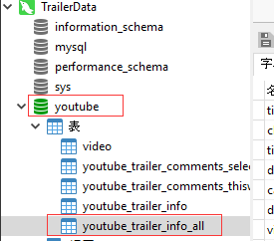
- Set field name like this:(English version is the same)
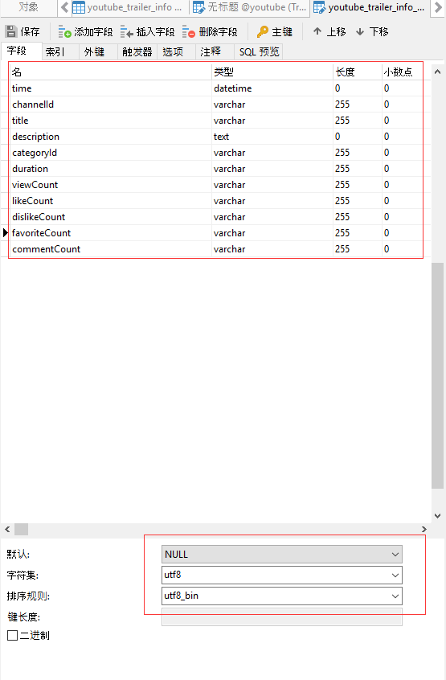
- Open Python Project youtube_trailerinfo_all, see the notes in code or see below.
  - Set Configuration Parameters at settings.py
  - Create api key at https://console.developers.google.com/
Choose Youtube Data API v3
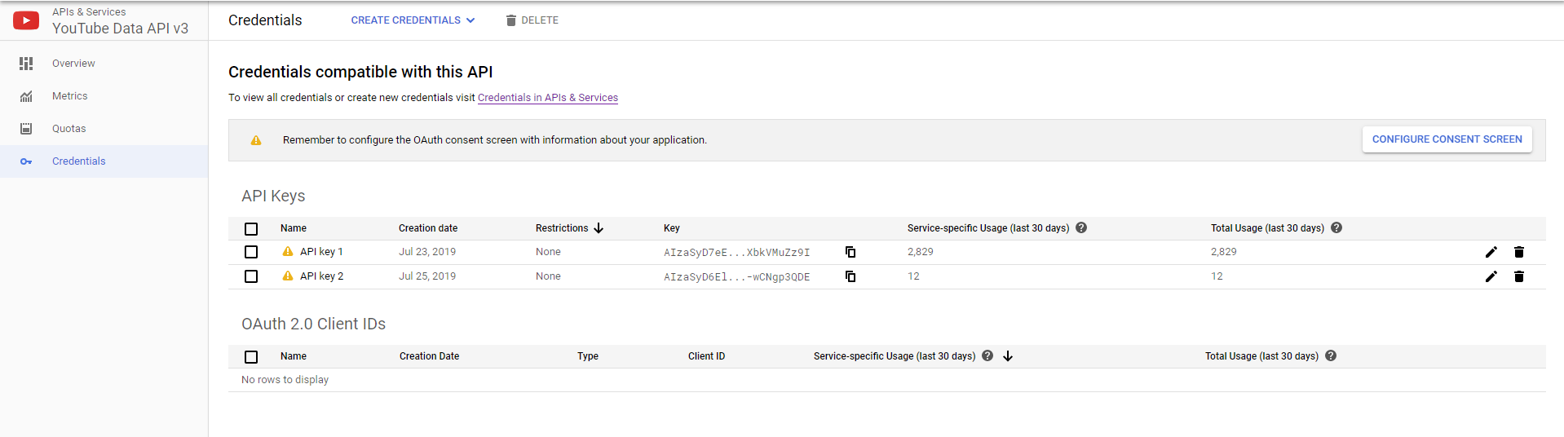
  - Set api key at youtube_scrapy_all.py line 40
  - Set Publish duration of data line 46, 55, 131, 159
  - Run

- youtube_trailer_comments_selected
Title of Trailer
Video Link()
Comments
CommentsLike(how many likes this comment get)
Comments Time

Steps: (I don’t use Python because the data is at different layers and the web using rolling to show, it’s difficult to achieve. However, the below method could even be used by people without coding experience, and could collect data from all kinds of websites without the risk of IP blocked)
- Install ScrapeStorm
- Copy the url(https://www.youtube.com/playlist?list=PLScC8g4bqD45-Bue4BX7U2h4IkzEV3hcL) and get started
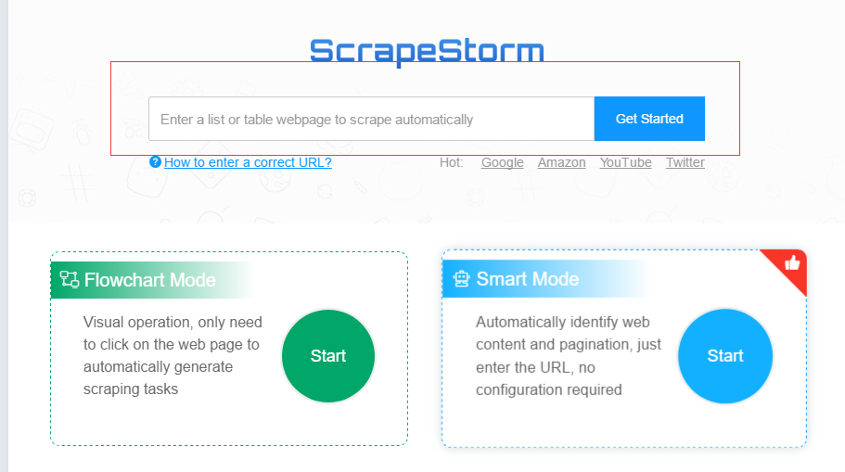
- Click Auto Detect and select the field name you want
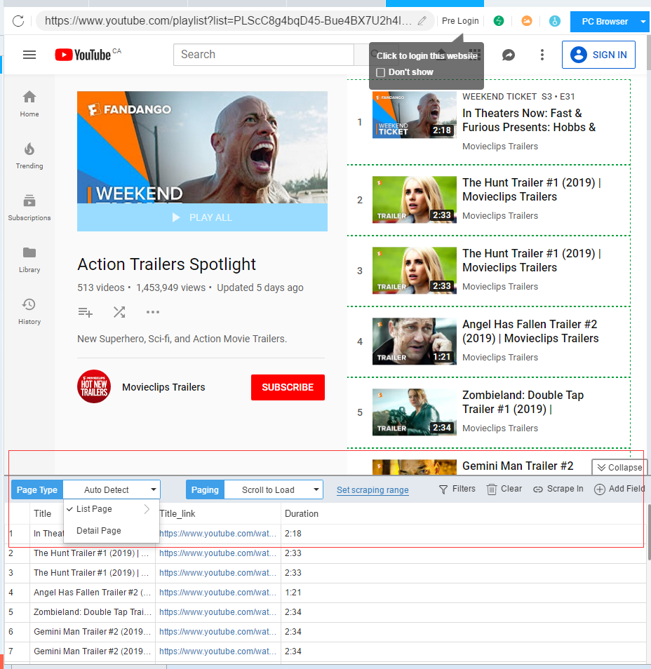
- Click “scrape in” in the right side of the above red box
- Click Select in Page and click 2 comments randomly, and select the field name you want
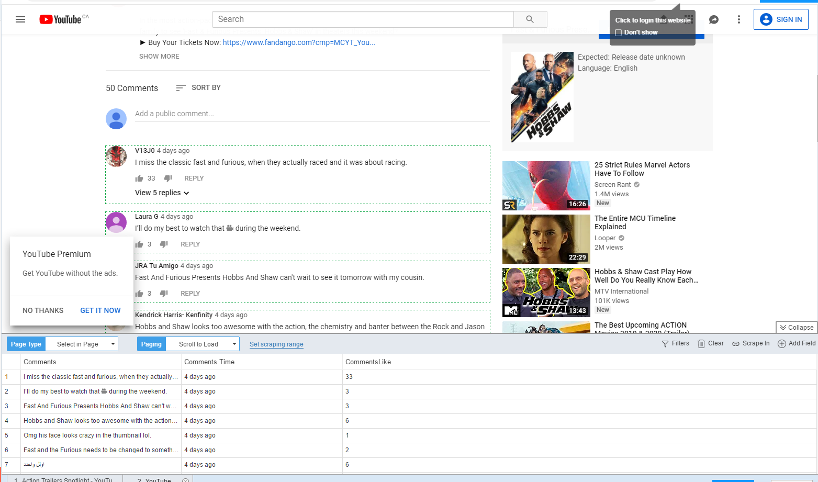
- Click Start and it would start scrape.(If you can’t get data at first, don’t worry, just wait, the loading time depends on viewers amount)

- After getting all data, click export and choose export ways.( Usually I would choose export to Excel, and then insert data from excel to mysql. Please be aware that the format of mysql datatable shoud be utfmb4 and utf8mb4_bin, because the some comments have Emoticon)
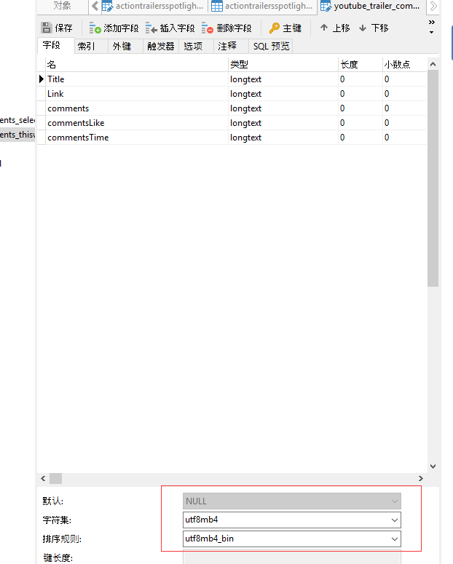

- Downloaded Videos
720P Biographical Trailer Spotlight
720P Comedy Trailers Spotlight
720P Drama Trailer Spotlight
720P Family & Animation Trailers Spotlight
720P Horror Trailers Spotlight
720P Hot Docs - New Documentary Trailers
720P NEW INDIE TRAILERS
720P Thriller Trailers Spotlight
720P Action Trailers Spotlight

Steps:
- Install Ummy Video Downloader
- Copy URL()
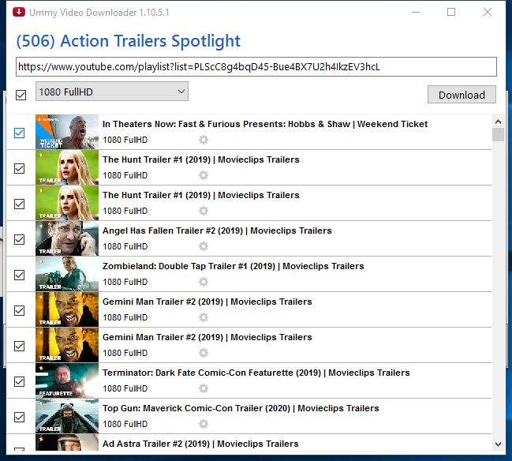
- Choose Quality and Download.
- Open these videos in python when you need to do analyse(File->Open->Videos)
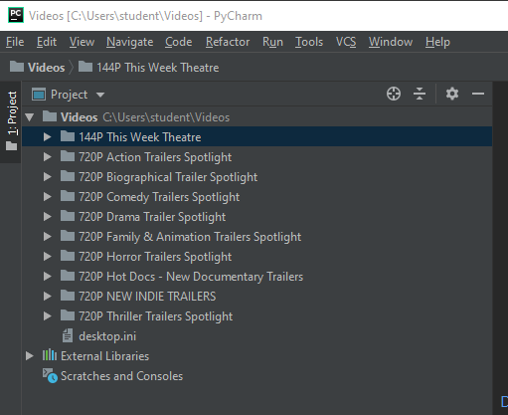
- Twitter_trailers_info_all (If Twitter is necessary, I would add this part in details)
Steps:
Same as Youtube_comments_selected, using ScrapyStorm, just use the url of Twitter.

Extended Program
The python project of “youtube” is a project which could get all data of all channels from youtube.(about 500 GB). This is a previous project of my friends and I.
You also need to change API key at youtubespyder.py.
You need to install Mongodb if you want to use this project. All setting would be completed automatically after you installed Mongodb. All you need to do then is wait...(500GB)

Summary

Four parts of my task:
- All data from Youtube Trailer Channel √
Published time, Title, Full description, Duration, ViewCount, LikeCount, DislikeCount, FavoriteCount, commentCount
(2018.1.1-2019.8.1)
700+ rows in total
- Comments from Youtube Trailer Channel √
Title of Trailer, Video Link, Comments, CommentsLike, Comments Time
(“This Week Theatre” — All comments of about 10 trailers) 8,500+ rows
(“This Week Theatre” — Selected comments of about 10 trailers) 800+ rows
(One category “Action Trailers Spotlight” — Selected comments of all 500+ trailers) 55,000+ rows
65,000 rows in total
- Download All Videos from Youtube Trailer Channel √
720P Biographical Trailer Spotlight
720P Comedy Trailers Spotlight
720P Drama Trailer Spotlight
720P Family & Animation Trailers Spotlight
720P Horror Trailers Spotlight
720P Hot Docs - New Documentary Trailers
720P NEW INDIE TRAILERS
720P Thriller Trailers Spotlight
720P Action Trailers Spotlight
(all 3000 trailers divided into 9 categories, 40GB, 7 kinds of quality could be chosen)
- All data from Twitter like sharing of trailers(Don’t recommend) √
(All 480 tweets including Title, URL, Comments, Tweet Time, LikeCount, ShareCount, ReplyCount, From, @who)

Problems and Improvements
Problems | Improvements
If one film has multi trailers, the data from Twitter and YouTube is difficult to match | Don’t use data from Twitter
Limits of API quota | Use different methods to get data.  Only youtube_info_all need api, and 10,000 quota is enough to get data from a whole year
The English version of ScrapeStorm is not free to export data.  95 dollars/month to export without limits, 49 dollars/month to export with 10000 rows/day | However we don’t need to be limited by api quota, and API could only get the most popular comments. In the short term it is worthy.
The Ummy Video Downloader is not free, 5 dollars/month

